**Assignment No. 8**

**Batch:** T6

**PRN No:** 2019BTECS00033

* **Title: Install & configure Oracle Advanced Replication server. Use Oracle**

**Enterprise Edition for multiple master sites.**

**Aim:**

* Use Oracle

Enterprise Edition for multiple master sites.

**Steps for Install & configure Oracle Advanced Replication server**

1. **System Requirements:**

8 GB of RAM; 80 GB of free space on the hard disk + staging area for Oracle Linux and RAC downloads, about 12 GB; This procedure was tested on 64-bit Windows 10.

1. **Download Software :**

OracleLinux 7

Mobile Xstream

Linux ISO file(4.5GB)

1. **Install the system Linux prerequisites**

The package oracle-database-preinstall-19c contains all the prerequisites on Oracle Linux using the Oracle Unbreakable Enterprise Kernel (UEK).

# yum update -y

# yum install -y oracle-database-preinstall-19c.x86_64

# yum install oracleasm-support

# yum install bind* -y

# sysctl -p

1. **OS level prerequisites (User creation + Network and System level changes):**
2. • Add the following entry in /etc/hosts file

127.0.0.1 localhost localhost.localdomain localhost4 localhost4.localdomain4

::1 localhost localhost.localdomain localhost6 localhost6.localdomain6

# Private

192.168.10.1 rac1-priv.localdomain rac1-priv

192.168.10.2 rac2-priv.localdomain rac2-priv

# Public

192.168.56.71 rac1.localdomain rac1

192.168.56.72 rac2.localdomain rac2

# Virtual

192.168.56.81 rac1-vip.localdomain rac1-vip

192.168.56.82 rac2-vip.localdomain rac2-vip

1. **Configure oracleasm on both the nodes as root user.**

**ScreenSHOTS OF Practical:**

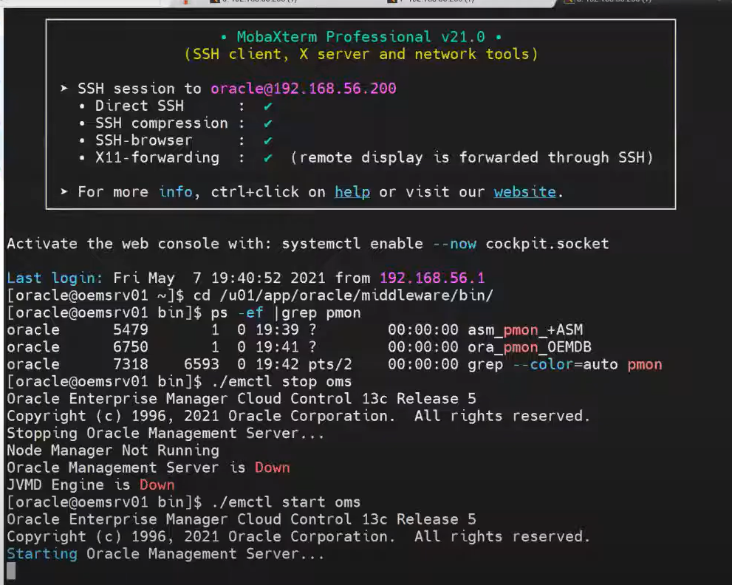

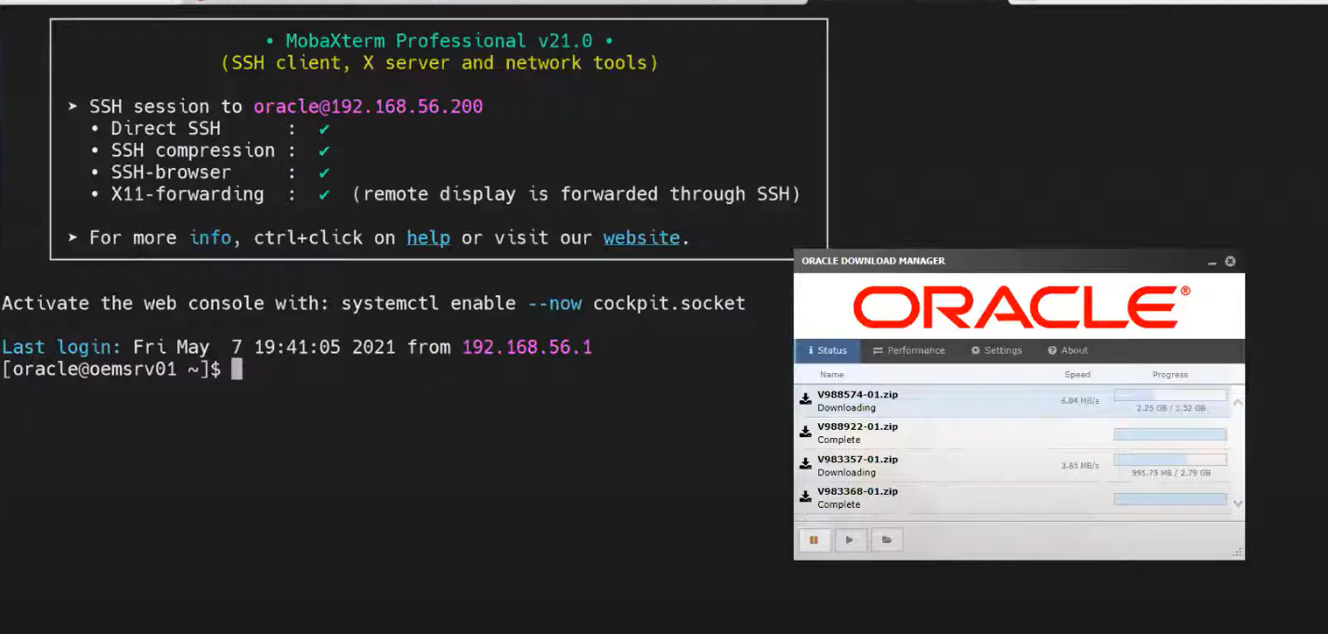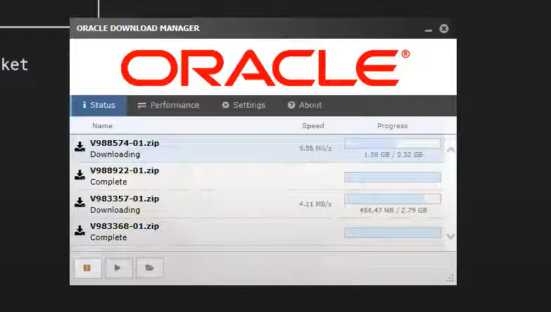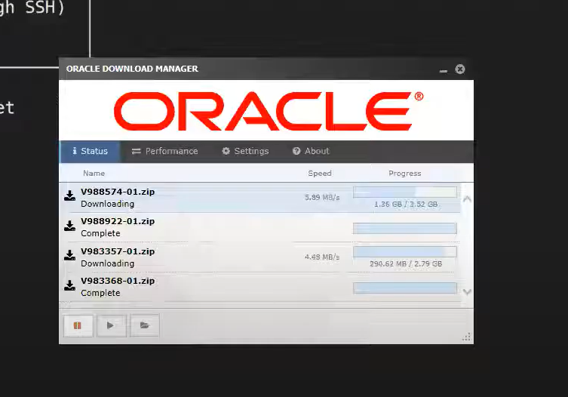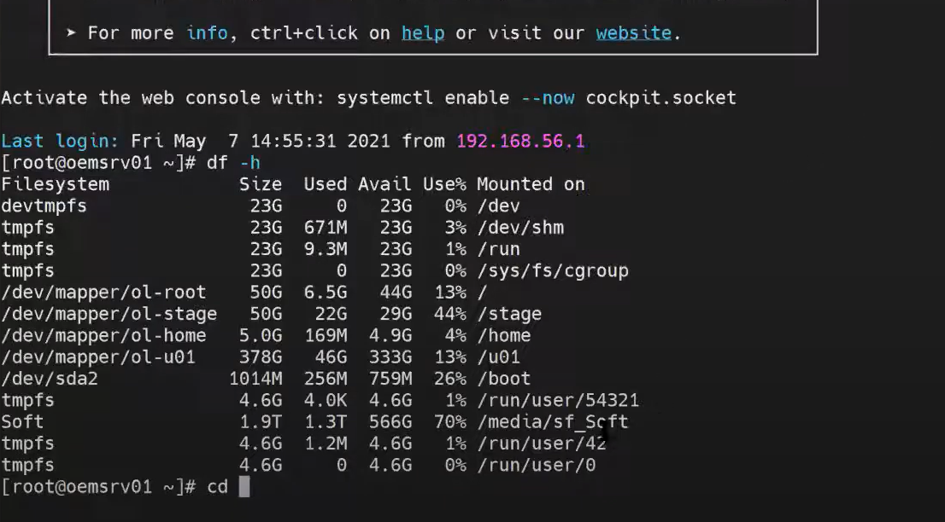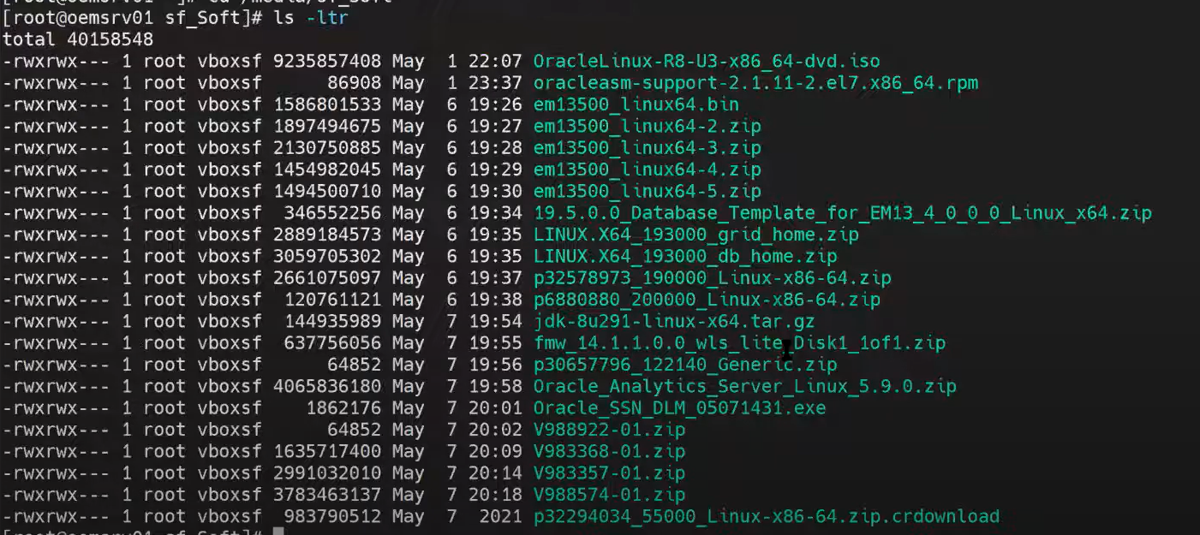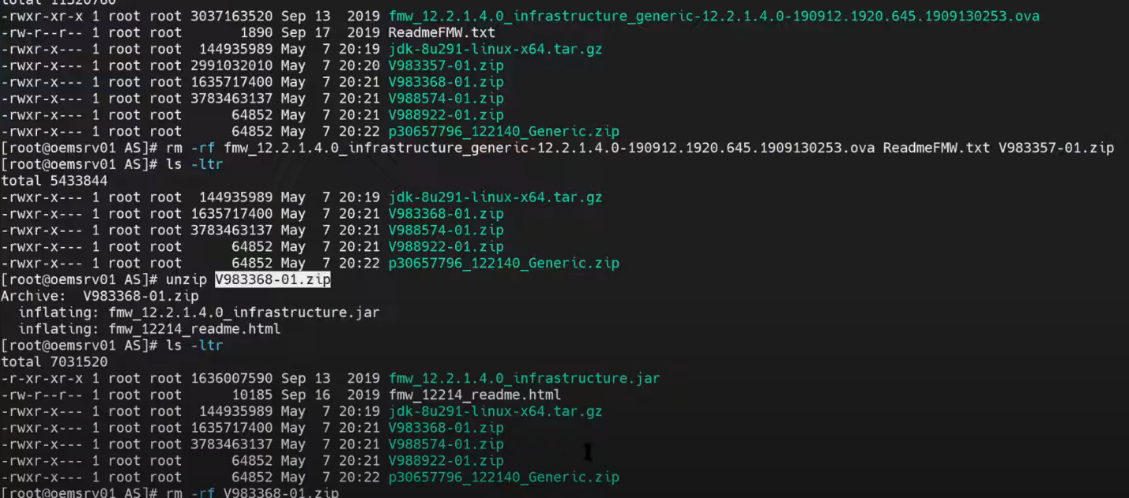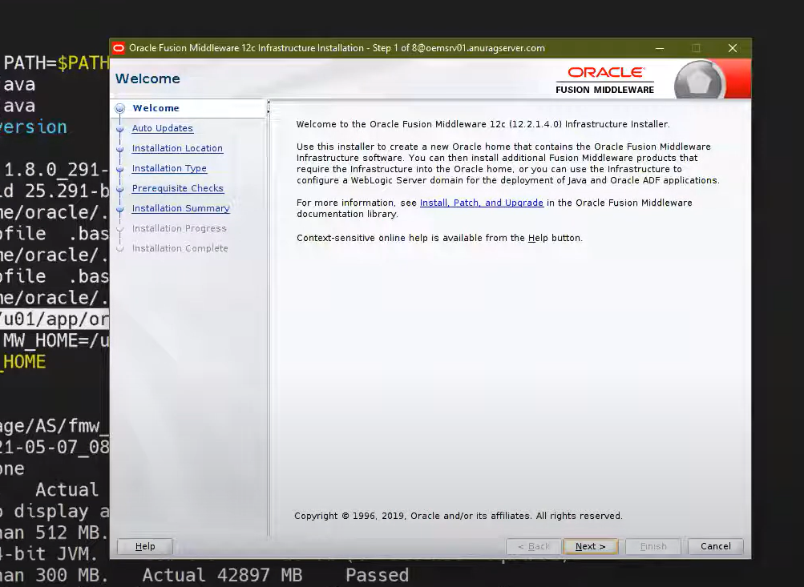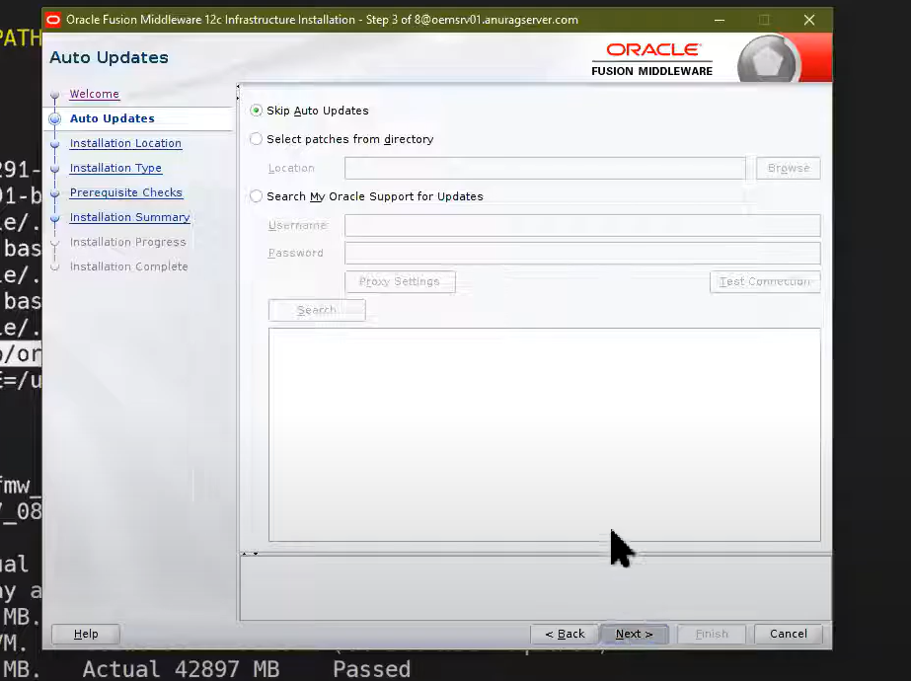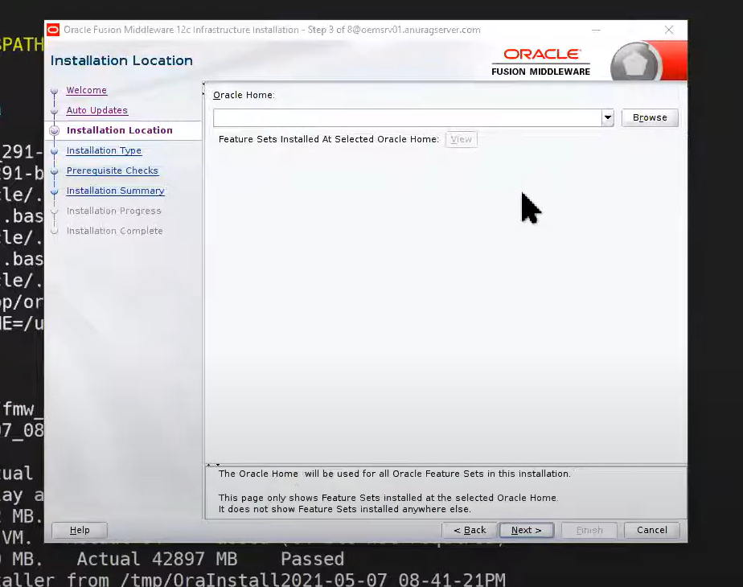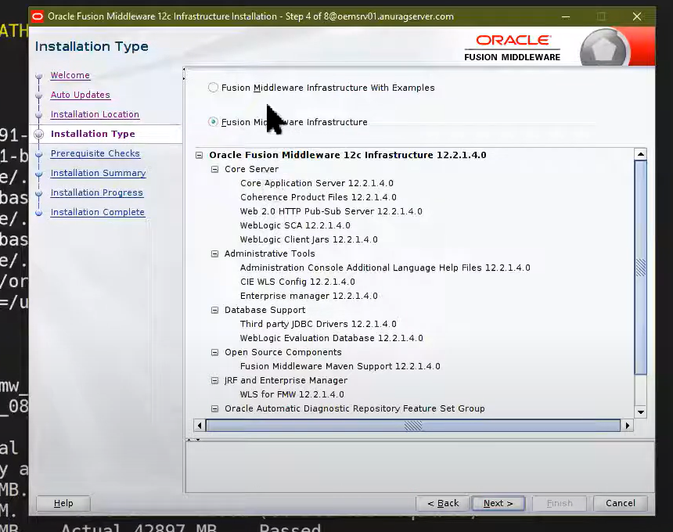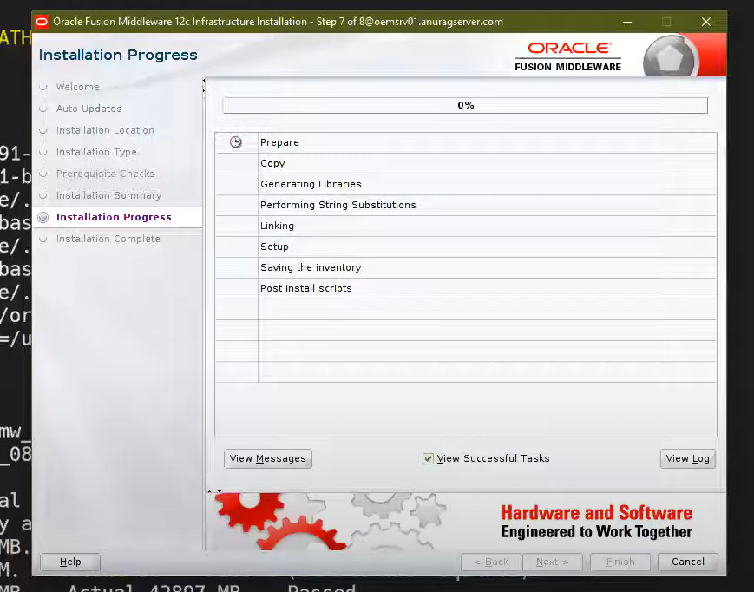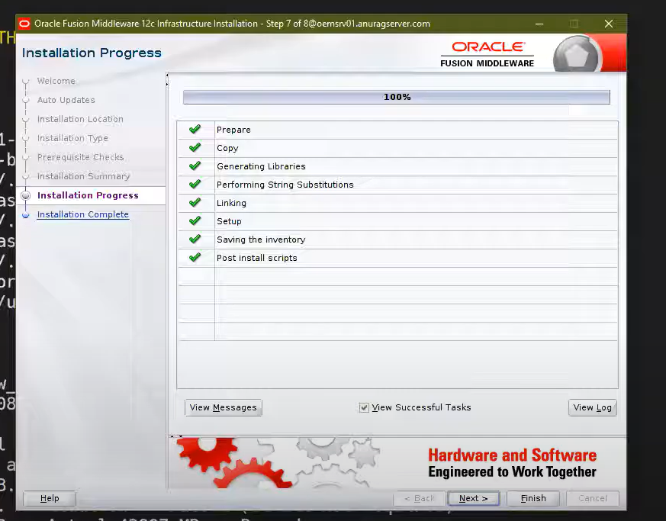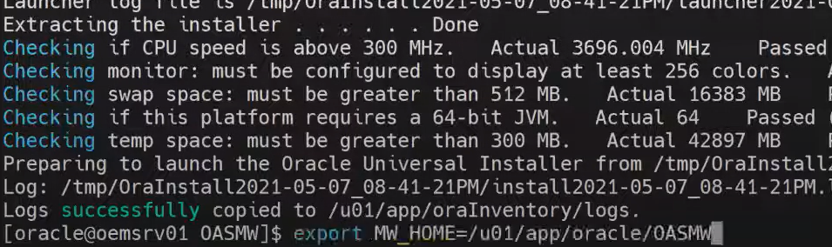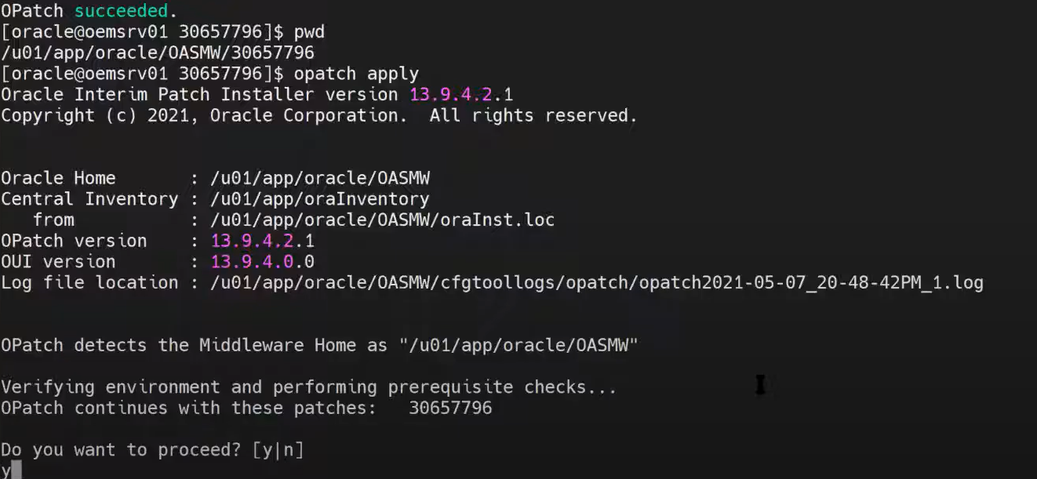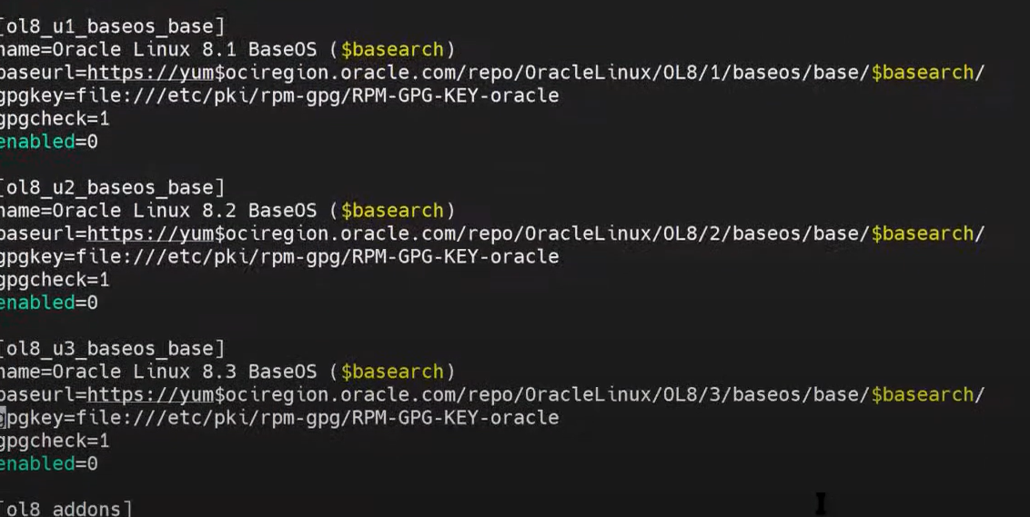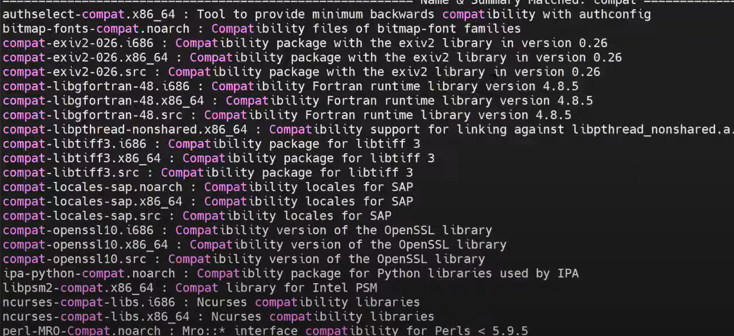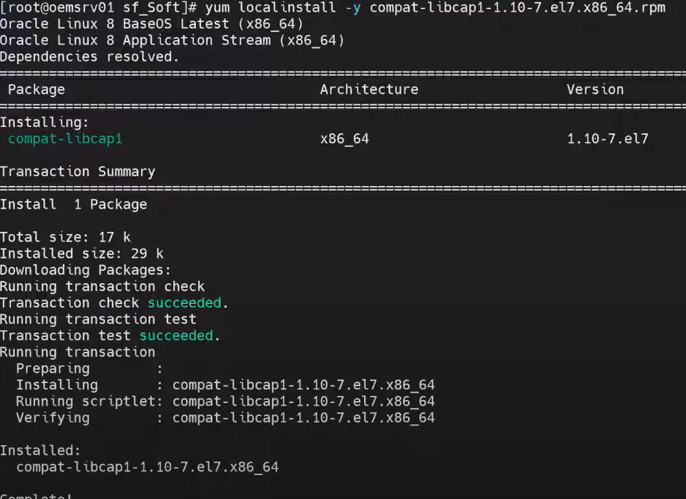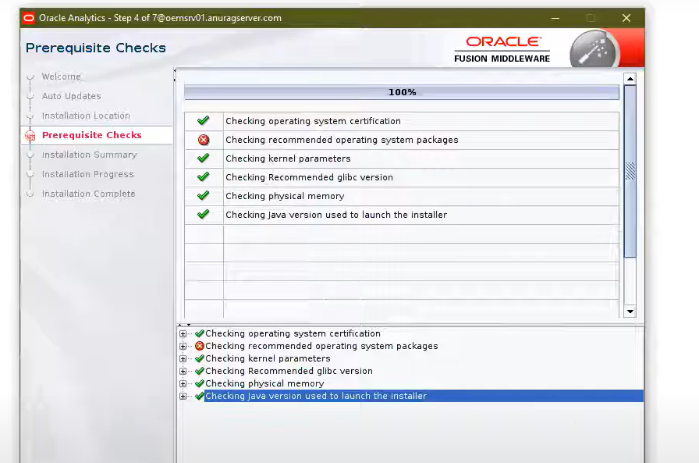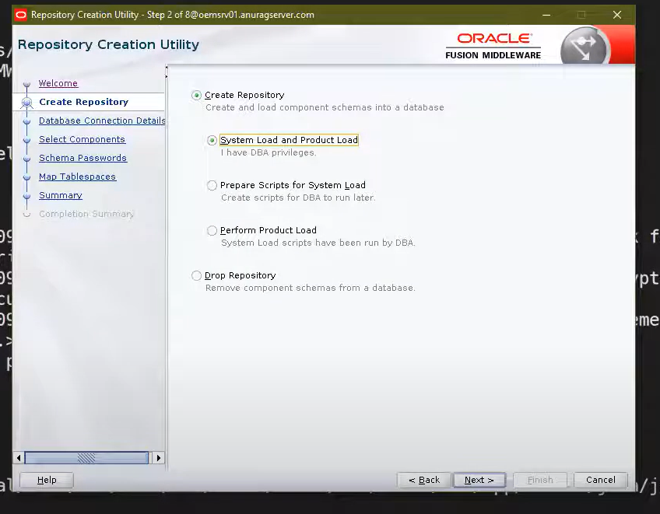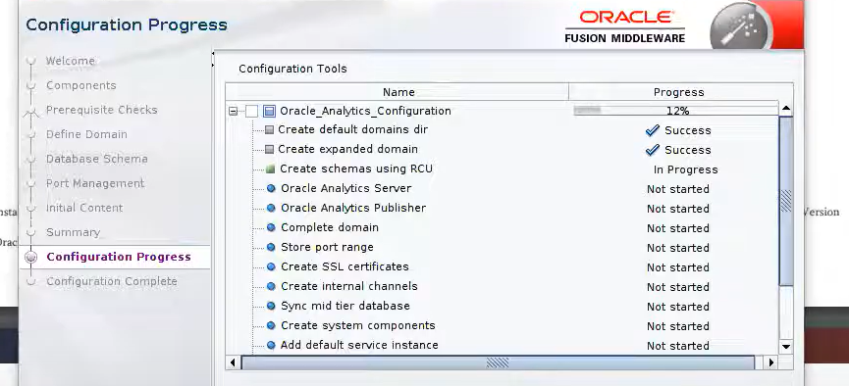

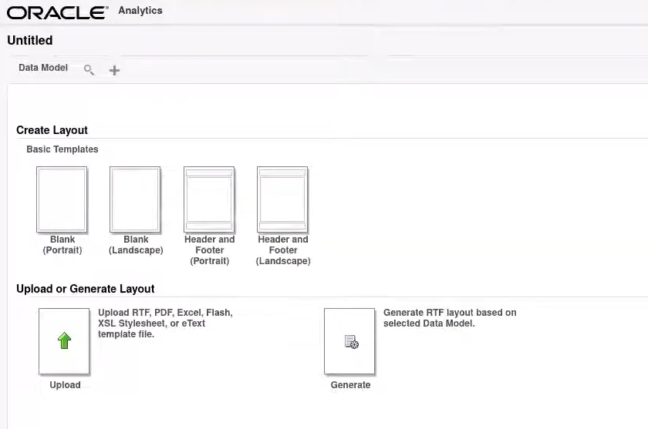

**Write Python desktop application to demonstrate the CRUD operations**

**on replica server.**

